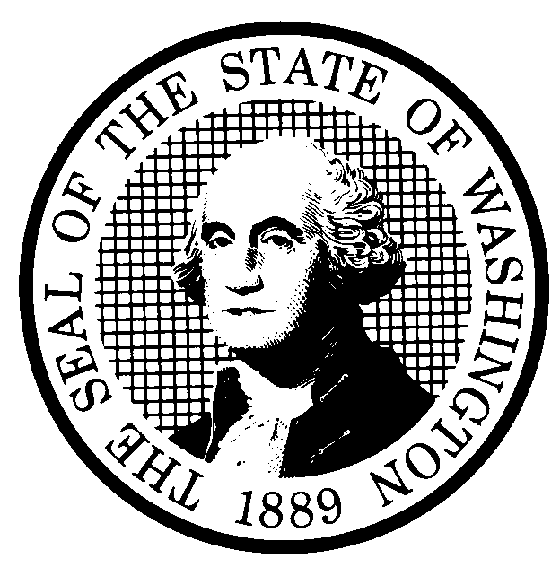  PREPROPOSAL STATEMENT  OF INQUIRY |  |  |  | CODE REVISER USE ONLY
CR-101 (October 2017)
(Implements RCW 34.05.310)
Do NOT use for expedited rule making
Agency:
Subject of possible rule making:
Statutes authorizing the agency to adopt rules on this subject:
Reasons why rules on this subject may be needed and what they might accomplish:
Identify other federal and state agencies that regulate this subject and the process coordinating the rule with these agencies:
Process for developing new rule (check all that apply):
☐ Negotiated rule making
☐ Pilot rule making
☐ Agency study
☐ Other (describe)
Interested parties can participate in the decision to adopt the new rule and formulation of the proposed rule before publication by contacting:
 |  | (If necessary)
Name: |  | Name:
Address: |  | Address:
Phone: |  | Phone:
Fax: |  | Fax:
TTY: |  | TTY:
Email: |  | Email:
Web site: |  | Web site:
Other: |  | Other:
Additional comments:
Date:  Name:  Title: |  | Signature:  Place signature here

